Lab 2 manual: Electric potential and equipotential lines
Dr. D. Beznosko
7/10/2022
For PHYS 1112L and PHYS 2212L
(Lab outcomes: advanced Excel skills, mapping of contour plot to experimental plot, electric field plot)

Abstract
This document describes the procedure to experimentally obtain the equipotential lines between the changes of different shapes, reproduce them in a spreadsheet software. In addition, electric field lines can also be drawn using the equipotential lines plots. Spreadsheet software is used to simulate the equipotential lines. Simulation is used to find the effective charge of the objects by fitting the scale and values of the potentials. Electric field lines are drawn.

Introduction
Electric field lines are the imaginary lines. What do they tell us, why do we draw them? How do they relate to potential and why it is easier to use potential and equipotential lines to find the field itself? Why electric field is always perpendicular to equipotential lines? Hint – can you explain this in your own words? Derivation will do as well but no extra points for it.

Experimental Setup
The Overbeck apparatus is shown in Figure 1 and contains the apparatus itself, field plate, the power supply, galvanometer, voltmeter, probe, and a clear design template. The experiment also uses a regular letter sized paper page, pencil, and a ruler (not shown).

Procedure
Choose one of the field plates. Turn the field mapping board over and attach a field plate to bottom (conductive (silvery) side facing out) with plastic-headed thumb screws. Connect the potential source to the two binding posts on the upper side marked "Battery or Oscillator." Fasten a sheet of 8.5"x11" paper to the upper side of the board. Select a clear design template containing the field plate configuration that you have chosen, place it on the two metal projections, and trace the appropriate design. Remove the design template.
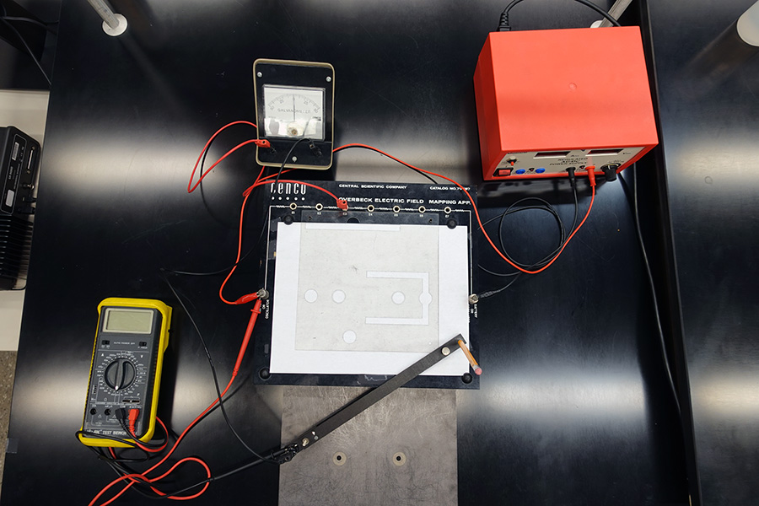
Figure 1: The experimental setup. Overbeck apparatus and other parts are shown and labeled. DON’T COPY ANYTHING FROM THE MANUAL!
Galvanometer
Voltmeter
Power supply
Clear design template
Probe
Overbeck Apparatus
Paper and pencil
Field Plate
Potential ports

Connect a wire to the first potential port and to the galvanometer. Connect another wire to the U-shaped probe and to the galvanometer. Carefully slide the U-shaped probe onto the mapping board with the ball end on the underside. Turn the potential source on to somewhere between 2 V and 5 V.
Gently glide the probe over surface until the galvanometer reads 0. Mark this position on the paper through the center of the hole on the top of the probe using a pencil. Move the probe to another spot where meter reads 0. Mark this spot. Repeat until you have mapped out an equipotential line. Repeat this for all potential ports. Connect points of equal potential to form equipotential lines. These should not intersect anywhere!
Use the ruler to draw the horizontal line that connects the center points of the charged objects (for a plane, it should be a perpendicular line). You can use the ruler also to estimate the center of the circular shapes.
Now choose an intersection of the equipotential and this new line. Connect the probe back to the right potential port and move it around trying to find the 0 reading of galvanometer around this intersection. Mark each point. The spread (i.e. stdev) of x-distance to these points is your error in locating each point.
Measure the total voltage from the power supply. Think about the chosen voltmeter scale and the reading error! Next, connect the voltmeter black wire to the probe and red wire to the apparatus power (normally, also red terminal or wire). On the same drawing, record the $\left(\frac{Totalvolage}{2}−currentvoltage\right)$ when the probe is aimed at each intersection of the lines – look though the opening for the pencil to aim the probe. Some values should end up negative.
Draw in electric field lines. Repeat this procedure for all provided plates.
What is the systematic error of the ruler? What about the voltmeter – does the manufacturer provide the precision that can be used as a systematic? Should be very small. Combine systematic and statistical errors into one as $\sqrt{statisticalerror²+systematicerror²}$ .

Experimental Data
The results of the measurements should be organized similarly to Table 1. Think about how to organize this table. The error can be listed in a different column or as value ± error unit. Choose a center of one of the charges (a surface for a plane) as 0 and measure distances to all intersections. Use SI units! Also record the total distance between change centers, plane surfaces or a change center and a plane surface, or other – depending on the field plate used.
Table 1: Experimental data for which field plate?
Distance, m | Potential, V

Provide description about each entry as needed, don’t just leave the table without text in this section. Organize well so that data takes less space, but everything needed is included.

Theory
Consider the equation 1 that described the dependence of potential U on position x.
$$U=\frac{1}{4πϵ_{0}}\frac{q}{r}\left(1\right)$$
with $q$ being the point charge, and $r$ - the distance from that charge. Always use equation editor and number the equations so that they later can be referenced as eq. 1 or equation 1. Other equations may need to be used for this lab. As potentials are scalars, they simply add together if there are multiple sources. Its useful to remember that $r=\sqrt{{\left(x−x_{0}\right)}^{2}+{\left(y−y_{0}\right)}^{2}}$ .

Analysis
For analysis, we will do yet another new thing using Excel or similar spreadsheet software. You are welcome to start with a provided excel template that matched the field plate that you have used in lab.
Start by setting up the x and y axes in the new spreadsheet. Use a row as x-axis and a column as a y-axis. Set up a realistic scale with a fine step (on the order of your position error? Larger? Smaller?) so that it starts before the position of first charged object and ends after the second. Choose the centers of the objects (i.e. charges) such that the distance between them is the same as measured from the drawing. Offset the coordinates of the centers by a number smaller than the chosen step – why do you want to do that? What happens if you don’t?
Set up one cell with the sum of two potentials from both objects. The initial values of q1 and q2 (or charge density, etc.…) can be random – one positive and one negative. Now set all cells within your chosen coordinate values to the same equation. If you zoom out, you should see something that resembles the drawing in some details. Make a contour plot of these values.
Next, adjust the q1 and q2 so that the potential values that you have recorded on the drawing will match as best as possible with the values in cells at the same location. Were you able to find such q1 and q2 (or change density)? How close these values are to the measured ones? Are they within the errors for the x-position and voltage measured?
The voltmeter measured the potential difference, not the potential itself – it can’t be measured as a reference point is needed. How about your measurements – are they valid values for the potential? Where is the 0 for your measurements?
In your report, show the photos of your drawings and contour plots of the spreadsheets. What is the q1 and q2 or charge density? What is the possible error on these values? You can try to estimate this by adjusting the charges so that the voltage you measured for each intersection moves around the intersection within the distance error (do this 5 times, stdev is the error). PHYS2212L only – from eq 1, express the change and find the $Δq$ for all the measured voltages and distances. Use the largest value and compare it with the value you measure from adjusting the charge method.

Conclusion
Remember to include references and appendices as needed. Comment on your result. What did you learn in performing this measurement? Where else can it be used? Can it be improved? Think about the comparison between the measured values and simulated – can some mathematical method be used to compare these or to look for the best charge values?

In your report, DON’T COPY this or any other section. I will consider copying any text from manual as error and lack of section even if you reference it, or even as plagiarism. Must be in your words, describing what you did in the lab. Might be different from this description as lab activities may not always follow the description provided exactly.
Another possibility is to measure shortest distances between all lines that you found and take the stdev of that measurement. This will also get a good estimate on the error of each point location.
Hint – can use the potential ports for the measurements, just remember which line corresponds to with port.

